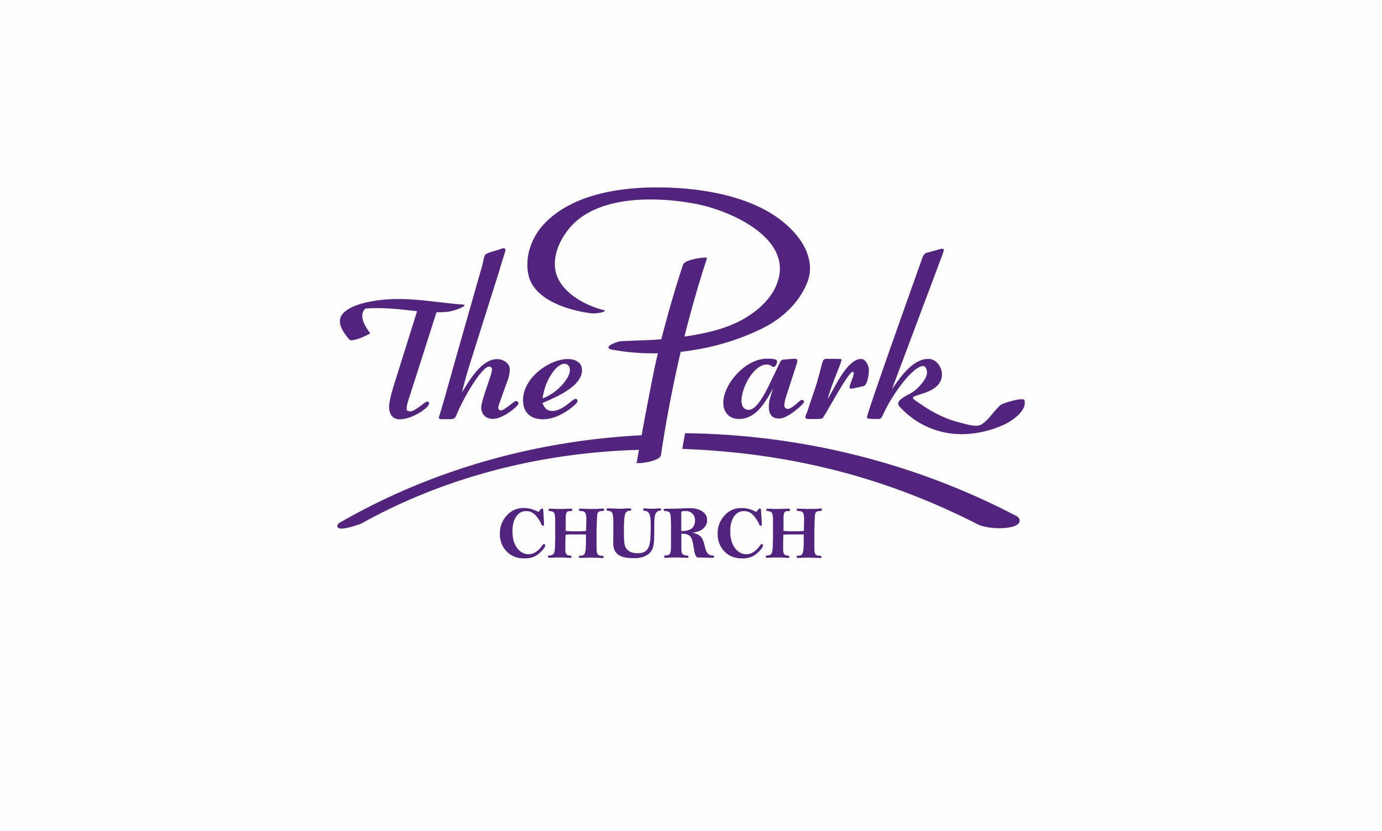
Soul Stepping Line Dance
Emergency Information Card

Waiver Statement 2025

Thank you in advance for taking the time to complete the information below. This information helps us to serve you better should an emergency occur while you are participating in activities that are related to the Family Life and Wellness Center, The Soul Steppers, The Park Property, The Park Church, Charlotte, NC.

PLEASE PRINT LEGIBLE

Date: ______________________

Last Name: __________________________________ First Name: ____________________________

Phone Number: (_______) ______________________ Date of Birth: __________________________

Email Address: _______________________________________________________________________

Name of Personal Doctor: _____________________________________________________________

Preferred Hospital: ________ Novant (Presbyterian) ____________ CMC

In Case of Emergency Contact:

Name: |  | Phone Number: | Relationship:
______________________________ |  | ___________________________ | __________________________
______________________________ |  | ___________________________ | __________________________
List Medical Concerns |  | List Any Allergies | List Medications
______________________________ |  | ___________________________ | __________________________
______________________________ |  | ___________________________ | __________________________
The Park Church
Pastor Claude Richard Alexander Jr. Senior Pastor
6029 Beatties Ford Rd. Charlotte, NC 28216
704-­‐392-­‐1681 * 704-­‐392-­‐7507 Fax
www.theparkministries.org
I, understand registrant, or parent/ guardian of registrant for the use of the Family Life and Wellness Center, The Soul Steppers, The Park Property, The Park Church, Charlotte, NC do hereby release and discharge The Park Church, and its authorized representatives, volunteers and staff on behalf of myself, and participants under age 17 or any guest against the church,
representatives, volunteers or staff from liability for any injuries occurring out of my use of the facility. Furthermore, in case of an accident or medical emergency, if the staff or representatives are unable to contact the parent(s)/ guardian (s) for participants, 17 and under, I hereby grant permission to said staff to administer necessary first aid and / or take applicant to the nearest hospital or medical facility for additional treatment. I understand that I am responsible for all ambulatory, hospital and medical fees that are associated as a result of my receiving the appropiate and necessary medical care.

I do hereby assume full responsibility for any and all damages, injuries, or losses that I may sustain or incur, if any, while attending or participating in any dance class, demonstration, form of practice and/ or physical activity. I hereby waive all claims against Family Life and Wellness Center, The Soul Steppers, The Park Property, The Park Church, Charlotte, NC, its instructors, or partners of said organization, individually or otherwise, for any and all claims for injuries or damages that I might sustain.

I have voluntarily agreed to be filmed or videotaped in connection with my interest in being a participant of The Park Church Soul Steppers Line Dancers. I hereby consent to the recording, use and reuse and/or any of their respective licensees, assigns, parents, subsidiaries or affiliated entities and each of the respective employees, agents, officers and directors (collectively “The Park Church and/or The Soul Steppers”) of my voice (including, without limitation, my speaking and singing voices and musical compositions created by me), actions, likeness, name, appearance and biographical material (i.e., collectively “Likeness”) in any and all media now known or hereafter devised, worldwide in perpetuity, in or in connection with: (i) my being considered for possible participation in the Program and (ii) the Program and associated promotion and exploitation of the Program (in any form or media) thereof. I agree that The Park Church and/or The Soul Steppers may use all or any part of my Likeness, and may alter or modify it regardless of whether or not I am recognizable. I specifically agree that The Park Church and/or The Soul Steppers shall have full exclusive ownership of any video taken of me herein (“Material”) and I shall have no rights whatsoever to the Material. I further agree that The Park Church and/or The Soul Steppers shall have the right to use the Material and my Likeness in any and all media now known or hereafter devised worldwide, in perpetuity.
I grant the rights hereunder whether or not I am selected to participate in the Program in any manner whatsoever. I release The Park Church and/or The Soul Steppers from any and all liability arising out of their use of my Likeness and/or the Material. I agree not to make any claim against The Park Church and/or The Soul Steppers as a result of the recording or use of my Likeness and/or the Material (including, without limitation, any claim that such use invades any right of privacy and/or publicity and any claims based on defamation or libel or false light).
I, the undersigned registrant, or parent/ guardian of registrant for the use of the Family Life and Wellness Center, The Soul Steppers, The Park Property, The Park Church, Charlotte, NC understand and am aware that the recreational activities conducted in and through the Family Life and Wellness Center, The Soul Steppers class, The Park Property and The Park Church, involve a risk of injury or death.

____________________________________ ___________________________________
THE PARTICPANT PRINTED NAME THE PARTICPANT SIGNATURE

___________________________ _____________ ____________________________________
Witness Signature Date CHILD: AUTHORIZED SIGNATURE

FOR UNDER 18 YRS OF AGE

